Pokhara University

Level: Bachelor | Semester – Fall | Year : 2011
Programme: BE |  | Full Marks : 100
 |  | Pass Mark : 45
Course: Control System |  | Time : 3 hrs

Candidates are required to give their answers in their own words as far as practicable.
The figures in the margin indicate full marks.

Attempt all the questions.

1. | - Obtain the mathematical equations describing the mechanical circuit shown in the figure below and draw its force current analogy.  K1  K2  B1  F(t)  X2  X1  M2  M1  - Using Mason’s gain formula find the transfer function of the system given below.  G1  G2  G3  H1  H2  H4  H3  R(s)  C(s) | 8  7
2. | - Obtain the transfer function of the system using block diagram reduction technique.  G1  G2  G3  H2  H1  G4  R(s)  C(s)  - Find the state space model of the given circuit.  V_{c}(t)  C  L  R  Ι_{f}(t) | 8  7
3. | - The characteristic equation of a closed loop system is given by s⁶+2s⁵+8s⁴+12s³+200s²+16s+16 = 0. Comment on the stability, and find the number of roots lying on the right hand plane and the frequency of oscillation.  - A unity feedback system has a forward transfer function of G(s) = 16/ [s(s+1)]. Determine the value of undamped natural frequency and damping ratio. If tachometer feedback is introduced, the feedback path transfer function becomes (1+Ks). What should be the value of K to obtain damping ratio of 0.6. | 7  8
4. | - Sketch the root locus for unity feedback control system whose open loop transfer function is given by  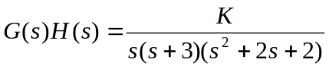  - The open loop transfer function of a unity feedback control system is given by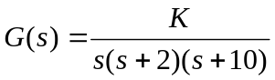. Find the static error constant and steady state error of the system when subjected to input r(t) = 1+ t + (t²/2). | 9  6
5. | - Draw the bode plot for the transfer function 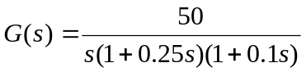 and find the gain margin and phase margin and comment on the stability of the system.  - Using Nyquist Criterion determine the closed loop stability of a system whose open loop transfer function is given by 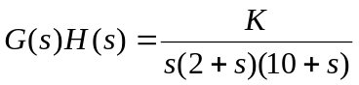 | 8  7
6. | The forward path transfer function of a control system is given by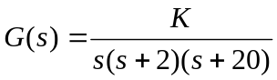. Design a suitable lag compensator having phase margin ≥ 35° and k_{v}= 20 sec⁻¹. | 15
7. | Write short notes on any two:  - Stability of a system  - Open loop and closed loop system  - PI controller | 2×5

